Good News
A business called MAPP decided this spring to support Family Equip as their charity. Mapp is a property management specialist for Fraser Property UK and they are responsible for Blythe Valley Business Park Solihull B90 8BG.
They raised £186 over Easter with a raffle and this month they are giving us the profits from the sale of hanging baskets. The two ladies, Susan and Deborah who serve the business park were keen to find a local charity to support and they liked our website and our ethos. When they put on their next fundraising event they would be happy to have any of our volunteers joining them. David (0121 709 1788) would be pleased to hear from anyone interested in helping them.
There is a nature walk available on that estate, Deborah is willing
to take us around, for a group of parents with children. Let me know if you are interested in such an event. -David

Please call 0121 711 8220 or email us on familyequipe2e@gmail.com to find out more. We are hoping to have a few one-off meetings for youngsters who used to come to the clubs called (16+ group). The next meeting will be Monday.
As a charity we depend on the gifts of a number of regular donors. Thanks to all our regular donors, we very much appreciate your gifts totalling over £200 a month.
Thank you to all our donors. We are truly grateful for this support!
Family Equip is staffed by volunteers of over 30 people regularly who help by giving their time and this helps us keep going.
Thank you so much!
Family Equip A Company Limited by Guarantee, Charity Registration No.1112769; Company Registration No 5596057
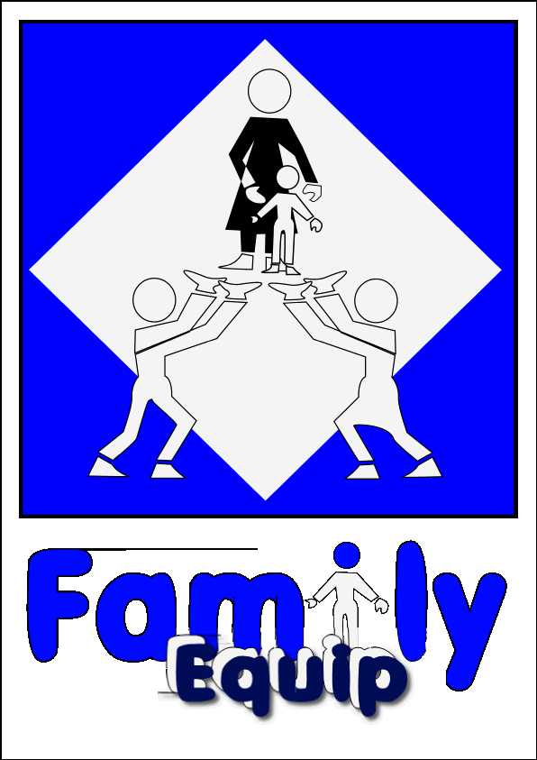

FAMILY EQUIP NEWSLETTER JULY 2022

News from FAMILIES and Volunteers
News from our volunteers
- Alex Manners
“Since the first lockdown, I have started to present my
Asperger’s talks online and my business has boomed. I am now presenting talks to companies and organisations all over the world. I recently presented 3 talks at the Autism shows in Manchester, London and Birmingham and sold over 100 copies,
of my book. As well as presenting talks, I am involved with another company where I deliver neurodiversity training to police forces all over the UK, also had an audition to be a presenter for BBC Kids
and I am in the middle of writing a second book.”

“The second book will be an improved and updated version of my first book. In my first book. My dad wrote a few paragraphs at the front about his experiences with all the challenges I faced at school. In my second book, I want a few other prominent people in my life to write about things from their perspective.”

- Saajan Mann
“I am on a Commissioning Course 221 at the Royal Military Academy Sandhurst, on track to pass out in December 2022 with the Queen’s Commission following my Maths degree from the University of Nottingham. I am sponsored to join either the Royal Engineers or Royal Signals as an Armed Forces Technical Officer. At the Academy, days are very long (you become familiar with both ‘5 o’clocks’ in the day). The course is intense and challenging but highly rewarding, focusing on military leadership doctrine and teamwork. Sandhurst is a unique environment filled with many traditions. Its primary focus is via its motto, ‘Serve to Lead,’
which I look forward to doing once I transfer to the Field Army.”

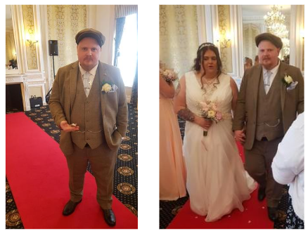
- James Pearse
James is one of our clubs’ ex members who then became a volunteer serving the Boys group when he lived in Shirley. He invited 2 of us to his wedding on the 4th June. Heather and David had the joy of attending the wedding of James to Sadie Edwards in Blackpool. They now live in a little village outside Cardiff called Maerdy. James loves the quietness of this village

- Manjinder Mann
Manjinder was a member of our first boys group. After leaving school, Manni studied at Manchester University a course in neurodiversity where he received a master’s degree. Following that he was very interested in becoming a doctor and studied at Glasgow University but that didn’t work out and then he went on to study in the USA. His experiences there has enabled him recently to now get a job at the BBC.

Do you know FAMILY EQUIP has a library of resources and you can borrow books at any time. Here are 2 books I recommend about OCD.
THINK GOOD FEEL GOOD
TALKING BACK TO OCD and one about ADHD called ADHD FOR DUMMIES
Call 0121 709 1788 to find out more or visit our website www.familyequip.co.uk

