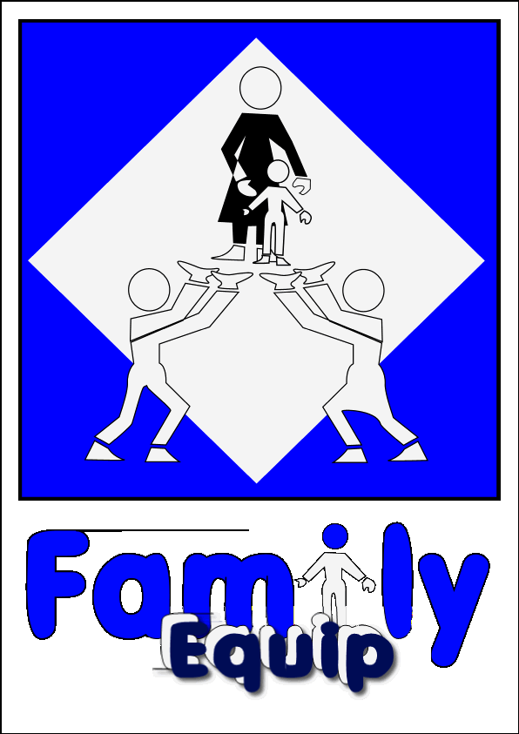
Gift Aid
To
Family Equip

Please treat my enclosed gift, any gifts I have made since 1st September 2019 and all gifts hereafter to FAMILY EQUIP as a Gift Aid donation, and I want the charity to reclaim tax.

I confirm that I am a resident in the UK and am a tax payer.

I understand the charity will reclaim 25p of tax on every £1 that I have given.

Donor’s details:

Title ____________ First name or initial(s) ____________________________

Surname ______________________________________

Home address ___________________________________________________

______________________________________________________________

______________________________________________________________

Postcode _________________________

Date ____________________________

Signature ________________________

H.M. Revenue and Customs
- You can cancel this declaration at any time by notifying the charity.
- You must pay an amount of income tax and/or capital gains tax at least equal to the tax that the charity reclaims on your donations in the tax year (currently 25p for each £1 you give).
- If in the future your circumstances change and you no longer pay tax on your income and capital gains equal to the tax that the charity reclaims, you can cancel your declaration (see note 1).
- If you pay tax at the higher rate, you can claim further tax relief in your Self-Assessment tax return.
- If you are unsure whether your donations qualify for Gift Aid relief, ask the charity, or the local tax office for leaflet
IR113 Gift Aid.
- Please notify the charity if you change your name or address.

A Company limited by guarantee number 5596057 Family Equip
Registered in England and Wales 2, Rollswood Drive, Solihull
Registered Charity Number 1112769 W. Midlands B91 1NL
Tel: 0121 711 8220 Email: familyequip@talktalk.net

