Research Project for Family Equip



By Claire Graham

University Provision



**Disability and dyslexia support**

The University of Birmingham is an inclusive learning community. Whatever your disability or learning support needs, we’re here to help make sure you have everything you need take full advantage of the student university experience.

The Equality Act defines a disabled person as someone who has a physical or mental impairment that has a substantial and long-term adverse effect on his or her ability to carry out normal day-to-day activities. This may include:

* A specific learning difficulty such as dyslexia, dyspraxia or dyscalculia
* A visual impairment
* A hearing impairment
* A mobility impairment
* A mental health condition
* Other unseen conditions

The University is committed to offering full support for any of these conditions that could affect your ability to perform on an equal level with your fellow students. Further information is available from the Disability Service.

For students with a mental health condition, such as depression, anxiety, schizophrenia or psychosis, support is available from the Mental Health Advisory Service.

The University also has an active programme of works to improve accessibility on campus. We have worked with Disabled Go to map the majority of our buildings across campus setting out the access to each of our buildings.

## Why should I tell the University I have a disability?

Shakleton10165x110We want to make sure that all our students get the most from university life. By telling tell us about your disability as early as possible, we can identify any support that you might need, including any financial support you’re entitled to.

The ideal is to tell us about it on your UCAS application form so we can discuss your support needs with you before you arrive. You could also be eligible for the Disabled Students’ Allowance (DSA) which can help to pay for a support worker or other types of assistance.

You’re not obliged to tell us about your disability, but if you choose not to, you may not be able to access the full range of support available. Please rest assured that any information you do give us about your disability is treated in the strictest confidence.

## When and how can I tell the University I have a disability?

We recommend that you inform us of any disabilities you may have and your support needs on your UCAS form. You need to fill in the necessary information on page 1, section 2 of the form (titled Personal Details), where you’ll find a list of codes covering a range of disabilities.

You can find further advice about disclosing your disability on your UCAS form can be found in the Students with Disabilities section of the UCAS website.

If you haven’t told us about a disability before you arrive, you can talk directly to a member of the Disability and Learning Support Service by calling +44 (0)121 414 5130 or emailing disability@contacts.bham.ac.uk.

## What support is available?

Whether you have a physical disability or health condition, a learning difficulty or mental health condition – even if you don’t consider yourself to be disabled – you’ll find we offer a range of professional support and advice.

Some examples of the kinds of support available  for disbaled students whilst at the university may include:

* Advice before you arrive at Birmingham
* Regular contact with the Learning Support Team, Disability Team or Mental Health Advisory Service
* Individual Student Support Advice Documents
* Liaison with departments and tutors
* Mobility maps of Edgbaston campus and Selly Oak campus
* Help with applying for the Disabled Students' Allowances (DSA) and other financial support.
* Guidance on arranging notetakers, readers and laboratory support
* Specialist support from professional Mental Health Advisors
* Loans of equipment including digital recorders where DSA provision is pending
* Book fetching, extended loans and assistive software in our libraries
* Effective learning workshops
* Support with examinations including extra time if needed
* Useful videos and resources for students with dyslexia

# What we offer

Our team of experienced staff offer a wide range of specialist advice and support in order that you may have the best possible experience at the University of Birmingham. This page gives examples of the kinds of support that can be availiable for disabled students whilst at the University

## Students with a disability or long term health condition

* Individual student consultations
* Provision of a written Student Support Advice (SSA) document based on your assessment.
* Screening if you think you may be dyslexic or dyspraxic - see dyslexia screening for more information
* Study skills advice - see effective learning for more information
* Assistance with provision of non-medical helpers to include notetakers and mentors - see provision of non-medical helpers page for more information
* Liaison with tutors and other university departments   
  Workshops and groups, including effective learning techniques, exam preparation, and well-being
* Advice about applying for the Disabled Students’ Allowances - see our DSA pages for more information
* Information leaflets, mobility map, Braille map
* Email distribution lists to keep you up to date with disability developments

## Students with specific learning difficulties including dyslexia and dyspraxia

* Dedicated homepage with tailored information for students with dyslexia or other specific learning difficulties - see Learning Support home page
* Individual consultations with the Learning Support Advisers
* One-to-one dyslexia tuition
* Dyslexia, dyspraxia or dyscalculia screening - see dyslexia screening for more information
* Advice about applying for the Disabled Students’ Allowances (DSAs) - see our DSA pages for more information
* DSA funded specialist tuition - see specialist tuition for more information
* Liaison with tutors
* Extended library loans
* Extra time for examinations
* Effective learning skills advice - see effective learning for more information
* Provision of a written Student Support Advice (SSA) document based on your assessment
* A drop-in service for students with specific learning difficulties on
* Wednesdays and Thursdays from 15.30 to 16.30

## Students with mental health conditions

* Dedicated homepage with tailored information for students with mental health conditions - see Mental health home page
* Confidential advice
* Short-term or ongoing support looking at possible triggers and coping strategies
* Information about the Disabled Students’ Allowances and help applying - see our DSA pages for more information
* An individual Student Support Advice (SSA) document
* Assistance with provision of non-medical helpers to include notetakers and mentors - see the provision of non-medical helpers page for more information
* Liaison with your tutors and welfare tutors
* Liaison with people outside the University, like GPs or Community Mental Health Teams
* Peer support groups – a chance to meet other people like you with similar experiences
* Wellbeing groups, offering a range of sports and activities
* Referral to the University’s Counselling and Guidance Service
* Advice for academic and support staff

## Students with autism or Asperger's syndrome

* Individual student consultations with a named key-worker
* Provision of a written Student Support Advice (SSA) document based on your assessment
* Specialist advice on assistive software, equipment and accessible formats - see assistive technology for more information
* Study skills advice - see effective learning for more information   
  access to peer support through the Student Mentor Scheme - see
* Student Mentor Scheme for more information
* Assistance with provision of non-medical helpers to include notetakers and mentors - see the provision of non-medical helpers page for more information
* Liaison with tutors and other university departments
* Extended library loans
* Extra time for examinations
* Information about the Disabled Students’ Allowances (DSA) and help applying - see our DSA pages for more information
* Online Asperger's portal, in collaboration with the Autism Centre for Education and Research (ACER) - see the Autism Centre for Education and Research website for more information
* Overnight trial stay in student accommodation for pre-admission students

Please note that you will need to provide evidence of a disability to register with us and access the full range of support available. Please see evidence guidance for more details.

# Information for disabled students

Disability can mean different things for different people. It may include you, even if you don't consider yourself to be disabled. If you have study support needs related to a disability, including dyslexia and other specific learning difficulties, mental health difficulties, autism, Asperger's syndrome, or other health conditions - we are here to help you.

[What we offer](https://intranet.birmingham.ac.uk/as/studentservices/disability/offer.aspx)

The range of support and assistance that we can provide for disabled students.

[Disabled Students' Allowances](https://intranet.birmingham.ac.uk/as/studentservices/disability/dsa/index.aspx)

An explanation of the Disabled Students’ Allowances (DSAs), and how to go about applying for them.

[Provision of non-medical helpers](https://intranet.birmingham.ac.uk/as/studentservices/disability/supportworker/index.aspx)

You may be entitled to assistance from support workers to include note-takers, readers, library help, and mentors.

[Assistive technology](https://intranet.birmingham.ac.uk/as/studentservices/disability/assistive/index.aspx)

The university has a suite of assistive technology systems to enable disabled students to carry out their studies and achieve their academic goals

[Disclosing a disability](https://intranet.birmingham.ac.uk/as/studentservices/disability/about/disclosing.aspx)

Information about disclosure, consent and data protection statement.

[Registration with our service](https://intranet.birmingham.ac.uk/as/studentservices/disability/registration.aspx)

Complete our online registration form to access support whilst at the University.

[Evidence guidance](https://intranet2.bham.ac.uk/as/studentservices/disability/Evidence-Guidance.aspx)

What medical or other evidence is required by the University.

[Reasonable adjustments (including exam arrangements)](https://intranet.birmingham.ac.uk/as/studentservices/disability/reasonable-adjustments/index.aspx)

Adjustments can be made for students with disabilities, including Specific Learning Difficulties such as dyslexia, dyspraxia and dyscalculia, mental health difficulties, autism or Asperger's and other long term health conditions.

[Preparing for University](https://intranet.birmingham.ac.uk/as/studentservices/disability/PreparingforUniversity.aspx)

A checklist to help you prepare for the transition to University, including how to apply for accommodation, a useful contact list and general living tips.

[How to find us](https://intranet.birmingham.ac.uk/as/studentservices/counselling/contact/directions.aspx)

Directions and photographs of the routes and buildings.

[Contact us](https://intranet.birmingham.ac.uk/as/studentservices/disability/contact/index.aspx)

More information about how to contact us by telephone, online or post.

**Weekly Drop-ins**

The Aston Webb Student Hub hosts weekly drop-in sessions during term time for current students who want to find out more about the services we offer.

Please be aware that appointments last for 10 minutes and you cannot pre-book.

**Disability Support -** Tuesdays, 1.30-3.30pm

**Mental Health Advisory Service -** Fridays, 1.30-3.30pm

**Learning Support  -** Wednesdays, 3.30-4.30pm , Thursdays, 3.30- 4.30pm

# Contact us

## Visit us in person

All of our services are now based in the Aston Webb Student Hub located on the main Edgbaston Campus.  You can find us on the campus map as reference R7.

You can view our opening hours online and find out more about the other services located in the hub.

## Disability Service

For general enquiries to the service, and for physical and sensory disabilities or ongoing health conditions.

* Email: disability@contacts.bham.ac.uk
* Tel: 0121 414 5130
* Web: www.intranet.birmingham.ac.uk/disability
* Browse FAQs and contact us online: www.studenthelp.bham.ac.uk

## Learning Support

For enquiries relating to specific learning difficulties such as dyslexia or dyspraxia.

* Email: learning-support@contacts.bham.ac.uk
* Tel: 0121 414 5130
* Web: www.intranet.birmingham.ac.uk/learningsupport
* Browse FAQs and contact us online: www.studenthelp.bham.ac.uk

## Mental Health Advisory Service

For enquiries specific to mental health difficulties such as depression or bipolar disorder, or autism and Asperger's Syndrome.

* Email: mentalhealth@contacts.bham.ac.uk
* Tel: 0121 414 5130
* Web: www.intranet.birmingham.ac.uk/mentalhealth
* Browse FAQs and contact us online: www.studenthelp.bham.ac.uk

## Contact us by post

If you need to send us any information by post please send to the following address:

Student Services Support Team  
Aston Webb Student Hub  
University of Birmingham  
Edgbaston  
Birmingham  
B15 2TT



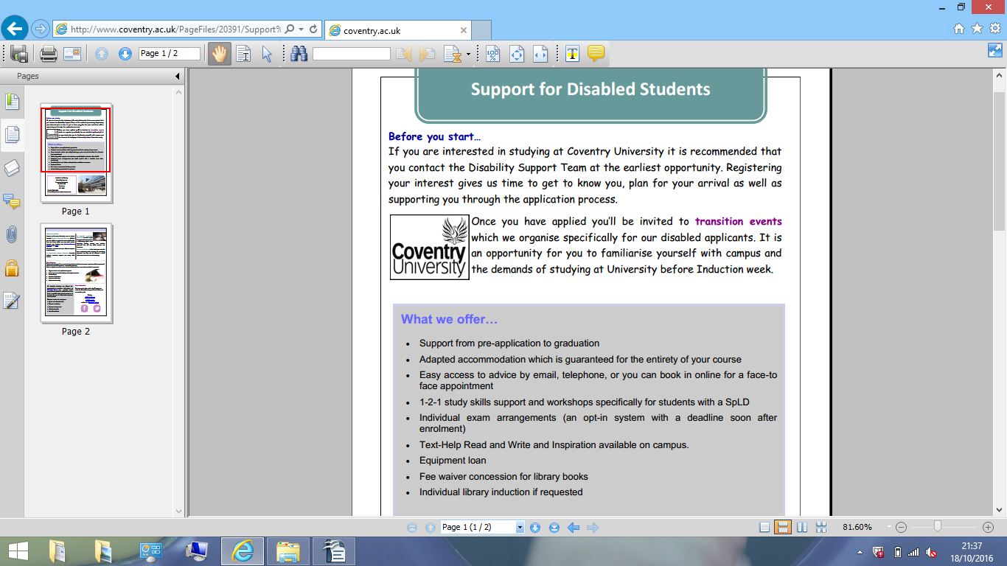

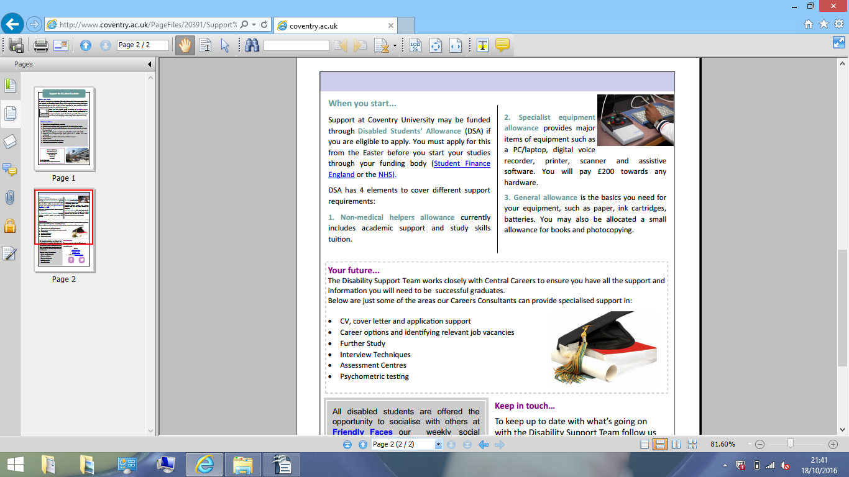

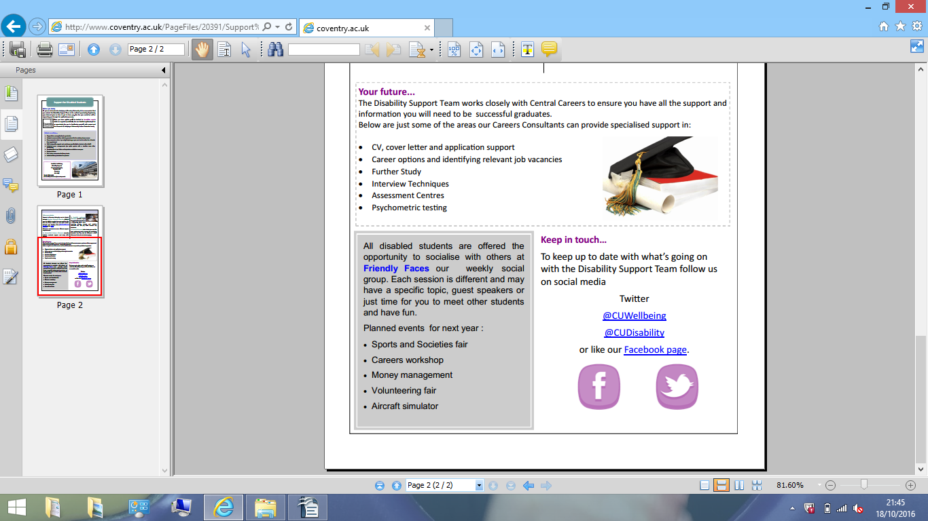



# Disability, Mental Health and Dyslexia Support

Newman University offers support to students with physical or sensory loss, mobility difficulties, long term physical or mental health issues, autism, or Specific Learning Difficulties, such as dyslexia, dyspraxia, dyscalculia or AD(H)D.  If you have any additional needs, please come and register with Student Support during Fresher’s week or early in the first semester.

Various types of arrangements and reasonable adjustments can be made to enable you to access your learning more readily, for example:

* We can liaise with academic staff to ensure that appropriate adjustments are made to learning, teaching or assessment processes.
* We can explore individual  exam arrangements or alternative assessments, if appropriate
* Use of assistive technology.

We also have a range of self-help resources available, and run stress management workshops and other awareness events throughout the year.

Additional funding to help support your study needs is available through Disabled Students’ Allowances (DSA), granted by your funding body, Student Finance England. This can pay for equipment or assistive technology and personal assistance such as a note taker, dyslexia support tutor, mental health mentor or BSL interpreter.  You are advised to apply for this funding before you enrol so that additional support can be put in place at the start of your course. To find out of you are eligible or to apply, please see [here](https://www.gov.uk/disabled-students-allowances-dsas/overview).

If you have any concerns about how you will manage a disability, health issue or Specific Learning Difficulty whilst at Newman University, or if you need particular arrangements to be made for you, prior to starting your course, please get in touch with Heather Griffiths, Inclusion Coordinator. Email: [h.griffiths@newman.ac.uk](mailto:h.griffiths@newman.ac.uk), or telephone 0121 476 1181 ext. 2421.

To find out more about the support available, or if you need particular arrangements to be made for you prior to starting your course, please get in touch with Heather Griffiths, Inclusion Coordinator. Email: [h.griffiths@newman.ac.uk](mailto:h.griffiths@newman.ac.uk), or telephone 0121 476 1181 ext. 2421.

Further information re support relating to different impairments or health issues can be found on the [Student Support pages of the Newman website](http://www.newman.ac.uk/disability/172).

**Key Contacts**

For mental health issues, e.g. depression, anxiety or a diagnosed mental health condition please contact  Lynne Whitlock, Mental Health Adviser. Email [l.whitlock@newman.ac.uk](mailto:l.whitlock@newman.ac.uk), Tel: 0121 476 1181 ext 2377

For any physical health issues, disability, Autistic Spectrum Disorder, or specific learning difficulty (other than dyslexia) please contact Heather Griffiths, Inclusion Coordinator. Email [h.griffiths@newman.ac.uk](mailto:h.griffiths@newman.ac.uk), Tel: 0121 476 1181 ext 2421

**Dyslexia Support**

If you suspect or know that dyslexia is a factor in your learning, please contact Becky Hartland-Fox ([r.hartland-fox@newman.ac.uk](mailto:r.hartland-fox@newman.ac.uk)), Newman's Dyslexia Advisor.  Becky can:

* Support you to complete a Disabled Students’ Allowances application to ensure funding for resources and dyslexia support
* Arrange a dyslexia screening appointment with you
* Outline the process for accessing Dyslexia Support at Newman.

Dyslexia Support is designed to teach you specific strategies to ensure you are able to demonstrate your full potential when tackling academic tasks.  The service aims to promote independent learning through effective metacognitive approaches.

Sessions are scheduled on a weekly basis.  Support will be timetabled and take place at the same time with the same dyslexia specialist each week and will be provided in line with assessment recommendations, your diagnostic profile of dyslexia, and your own identified support requirements. In order to ensure that the support you receive is specific and monitored, you will agree SMART targets with your tutor and review these each semester.

Because the demand for Dyslexia Support is high, we encourage you to get in touch as soon as possible so that support can be discussed and arranged.

If you have general questions about dyslexia or Dyslexia Support Services, please contact Lorraine Loveland-Armour, Newman's Dyslexia Support Services Team Leader for more information on 0121 476 1181, ext. 2519 or by email at: [l.loveland-armour@newman.ac.uk](mailto:l.loveland-armour@newman.ac.uk)

**Support Available**

The Disability Team co-ordinate services for students with disabilities and we can:

* Provide assistance with applying for the Disabled Students' Allowance (DSA) or other available funding
* Offer information and guidance relating to the DSA Needs Assessment
* Liaise with your School and Exams office to organise individual examination arrangements
* Arrange an appointment for a diagnostic assessment for Dyslexia or other Specific Learning Differences (SpLDs)
* Arrange Study Support Workers, BSL interpreters, Mentors, Dyslexia / Specialist Support Tutors, etc.
* Liaise with Residential Services, if adapted accommodation is required
* Assist with any general queries relating to disability advice.

## Admissions-related Disclosure

### How will you deal with my application?

If you declare a disability on the application form for your course, the relevant admissions team will contact us. We will then write to you for more specific information and to find out more about  the effects your medical condition may have on your studies and daily life; we use this information to assess the support you may need.

We will also provide information on the Disabled Students' Allowance (DSA), which may be available to help pay for any extra costs you may incur as a direct result of your disability or medical condition. For example, you may need a Mentor or 1:1 support from a Study Skills Tutor.  For more information on the DSA check out their [web page](https://www.gov.uk/disabled-students-allowances-dsas/overview).

We may invite you to attend an informal meeting to discuss your support needs – this gives you the opportunity to look around campus and chat with us about your support needs face-to-face. We will try and arrange for this meeting to coincide with a University Open Day so you can talk to both support and academic staff at the same time.

If we do invite you for a meeting and you have specific requirements, for instance, you need to park a car close to the University’s Main Building, or you require a BSL interpreter etc., please let us know in advance and we will try to accommodate your requests

### Why are you asking for details of my disability or asking for evidence?

We ask for this information so we can assess what support you may require and then, with your permission, we are able to liaise with the respective academic departments and central services to ensure the necessary support arrangements are put in place.

### Will my application be rejected if I have high support needs?

Any information you provide will be dealt with confidentially and separately from your academic application. However, other issues may have to be taken into account such as your suitability for the course, Health & Safety issues etc.  For example, if you tell us you are allergic to all types of metals and are applying to do a mechanical engineering course, then we may need to work with the academic department to look at some adjustments to the teaching programme. However, there may be situations where this is not practical or not possible, and the University may suggest more suitable courses

**Work Placement Support**

Starting the search for your placement is both exciting and challenging and it is important that you are aware of all the support, which may be available to you during this period.

## Where can I get support?

You are welcome to contact the Disability Team for assistance and advice during your placement search and whilst you are on placement. Advice and guidance can also be sought from the Placements Team and Careers Centre. The level of support available will depend on the type of placement you choose, for example, some placements may mean that DSA funding is not applicable or available for that year.  However, the Disability Team can advise you on specific circumstances and funding options.

For Disabled Students Allowance informaion visit our [Funding page.](http://www.aston.ac.uk/current-students/hub/thedisabilityteam/funding/)

If you have not already disclosed to the Disability Team you are more than welcome to contact us for an informal chat. Together we can explore what support and advice might be available, even if you later decide not to register with us formally.

The Disability Team can advise you on software and a variety of strategies you can put in place throughout your placement search and beyond.

[University counsellors,](http://www.aston.ac.uk/current-students/health-wellbeing/counselling/) the Health Centre, the Disability Team and the [ARC](http://www.aston.ac.uk/union/advice-welfare/advice/) (Advice and Representation Centre) are all still able to support you if you are on placement locally.  If you are moving away for your placement your local GP may be able to advise you of someone near your placement location who you could register with for the duration of your placement

The Disability Team can arrange for certain support to continue during your placement, if appropriate funding is in place. For example, our Study Skills Tutors may be able to support you using Skype.

## Should I disclose my disability to employers?

Deciding when and how to provide information about your disability is a very personal decision.  During your placement search you may be asked on application forms or during the interview stage whether you have a disability.  Disclosing early in the process and during the application stage does allow the employer to prepare any necessary provision.  These may be things such as extra time on a psychometric test if you are dyslexic or ensuring easy access or ground floor interview rooms and parking if you have mobility difficulties.  You may find it easier to disclose when face-to-face, during the interview stage.

**You may feel that your medical condition or disability will have no impact on your ability to do the job and therefore feel you do not need to disclose.  Before making your decision you may wish to talk it through with DANU.  Even if you are not registered with us you can still pop in for an informal chat.**

**Placement Support**

Whatever you decide, here are some handy Do’s and Don’ts if you choose to disclose:

Do:

* Provide positive examples of when you have overcome challenges
* Demonstrate that your disability has not limited any of your personal achievements, study or work experience
* Be prepared for the interviewer to ask you about your disability
* Try and anticipate any anxieties that the interviewer may have
* Provide factual information about your disability if required (but avoid the use of any complicated medical terminology: you will understand your disability or medical condition; the interviewer may not)
* If you wish, you can provide a copy of your Educational Psychologists Report to the employer with the key areas highlighted

### Don't:

* Assume you are going to be viewed in a negative way by the selection panel
* Allow an interviewer to make your disability or medical condition the focus of the interview
* Allow room for doubt: be positive about your skills and abilities