AVOIDANT AND RESTRICTIVE FOOD INTAKE DISORDER
My favourite food is chocolate crispy cake. I only like them if they’re melted. I wouldn’t want to try new foods because they might make me sick. I only like crunchy things. At birthdays I have a cake and I make a wish and blow out the candles but I never try it. I once had a tiny crumb of birthday cake but it made me feel sick.

Elizabeth Shea from The Birmingham Food Refusal Service (www.foodrefusal.co.uk) has provided some helpful insights into how to encourage Autistic children with a history of diet issues.

The relatively new diagnosis of ‘Avoidant and Restrictive Food Intake Disorder’ describes the selection (and rejection) of foods based on their sensory characteristics. It is well documented that individuals with ASC have significantly different sensory experiences than neuro-typical individuals which include both hyper and hypo sensitivities. In the context of eating, this means being more or less sensitive to how foods:
- look
- smell
- taste
- feel

Other sensory systems which are necessary for eating are:
- proprioception (body awareness)
- vestibular (balance)
- interoception (awareness of internal states).

In particular, interoception enables the recognition of hunger and satiety, the awareness of which is often reported to be impaired in individuals with ASC.

If you would like to read more on this article, here is the link to the web page:
http://network.autism.org.uk/knowledge/insight-opinion/understanding-and-managing-eating-issues-autism-spectrum

Family Equip, A Company Limited by Guarantee, Telephone: 0121 711 8220;
Charity Registration No 1112769; Company Registration No 5596057,
David Wort, Manager, 2 Rollswood Drive, Solihull B91 1NL
 FAMILY EQUIP NEWSLETTER
May 2016
SUPPORT FOR FAMILIES
Since January, the team has supported 19 new cases and numerous ongoing situations. We have had 2 parent support meetings. In February we discussed diet issues (see special article following) and problems in a particular primary school. Unfortunately our conclusion was that this school has a poor history of supporting children with additional needs
In March our meeting was about identifying and understanding unhelpful thinking. During this meeting other considerable concerns were raised in two areas:
1. Failure of the LEA in providing EHC plans.
2 The lack of CAMHS provision available and the failure of the service in giving repeat prescriptions.
We have recently set up a base for resources helping youngsters with sensory issues. This has now started and 3 families have benefited already. Here is a quote from one mother “thank you from the bottom of our hearts for the weighted blanket for A, its helped massively. He is now sleeping in his own bed!" One 13 year old now uses the privacy pod when he his stressed and his mother even uses it.
WHO IS WHO IN FAMILY EQUIP
TRUSTEE - LAURA BATES
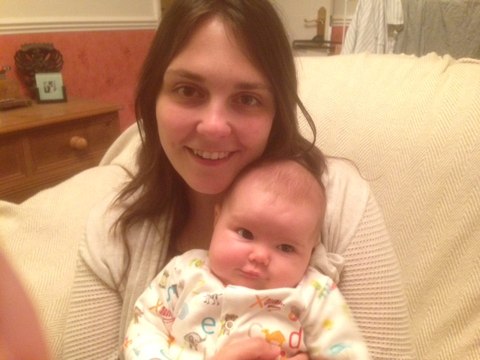
My name is Laura and I've been helping to run the girls and siblings group since it began back in 2006.
It's been wonderful to watch the club develop from a few girls to the larger group we have today! What blesses me most is to see those young people return as helpers, encouraging others in ways they were encouraged.
It was through volunteering for Family Equip that I came to the decision to train as a mental health nurse.

When I'm not on maternity leave I work for Worcestershire Child and Adolescent Mental Health Services (CAMHS) as a Community Psychiatric Nurse. This involves the assessment and treatment of mental health issues in young people aged 5-18. In January I completed a post graduate qualification in Cognitive Behavioural Therapy at the University of Reading.
Since having our first baby, Ada, born in February 2016, I can mostly be found in coffee shops! Ada and I have visited the Siblings group in April and will be meeting the Girls group in June.
SUPPORT FOR YOUNG PEOPLE
In the year since April 2015 we have had 72 young people benefiting from our work in the Therapeutic Clubs. We have provided 20 therapeutic clubs during this period and have followed the theme of 'Identity'. During the summer months we are following the theme of 'Responding Skills'. We are hoping to encourage youngsters to respond in the following ways - 'Appropriately', 'Respectfully', 'Considerately', 'Encouragingly' and 'Humorously'.
We have submitted our end of project report to BBC Children in Need. Once this has been approved we will be able to make a bid for funds for a year from September 2016.
Here is an extract from the report
Additional Benefits: One member of the club, as a young teenager, struggled to show empathy with others, particularly his sisters. He learnt a lot through the clubs and now helps as a volunteer. Since leaving school he is following a media studies course. He has a part time job with a small media company. As a result of learning in our club he has asked Family Equip for some of our materials to do with Empathy. He is hoping to produce short visual clips for children like him to understand how others feel. He recently appeared on Television explaining his Autism and has applied for an apprenticeship with the BBC at the Mail Box.
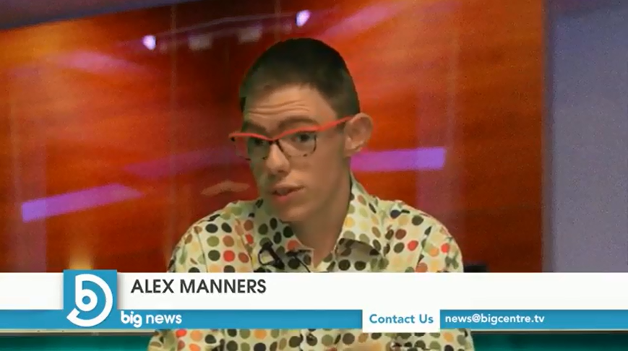



40 children and 12 adults enjoyed a trip together to Cadbury World on Monday 4th April, particularly the 4D experience, the special pass so we didn't have to queue and the free chocolate!



FUNDRAISING

Thank you to all of our regular donors. We are able to progress with your support

Dominique Hazzard has helped us plan A FUNDRAISING FUNDAY on Saturday afternoon 2nd July at 3pm at The Bridge
We have a number of roles which people could volunteer for - please speak to Dominique on 0121 745 2345 (if you leave a message, please repeat your number slowly, thank you) or call Family Equip on 0121 711 8220 if you would like to be involved.
We would like to sell unwanted children’s' toys and books, possibly we will also have a bric a brac stall which, if the weather is good, will take place outside and we will be selling cakes.

We will have fun things such as a crystal maze, human battleships, dodge ball, a wheelbarrow race and a treasure hunt which could take place in the park.

